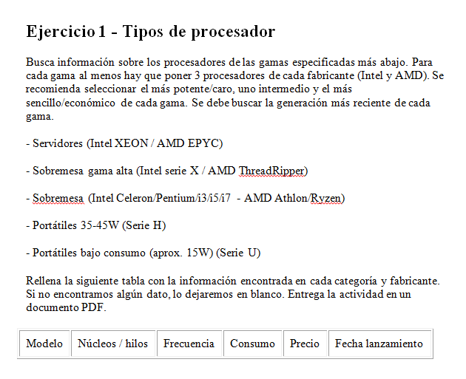

|  |  |  |  |  |  |
| --- | --- | --- | --- | --- | --- |
| Modelo | Núcleos/  hilos | Frecuencia | Consumo | Precio | Fecha lanzamiento |

|  |  |  |  |  |  |
| --- | --- | --- | --- | --- | --- |
| XEON PLATINUM 8280 | 28/56 | 2.70-4.00GHz | 205W | 10009$ | Abril 2019 |
| XEON  W 3245 | 16/32 | 3.20-4-40GHz | 205W | 1999$ | Junio 2019 |
| XEON  E2186G | 6/12 | 3.8-4.7GHz | 95W | 450$ | Julio 2018 |
| EPYC 7742 | 64/128 | 2.25-3.4GHz | 225W | 6950$ | Agosto 2019 |
| EPYC 7352 | 24/48 | 2.8-3.35ghZ | 155W | 1466$ | Agosto 2019 |
| EPYC 7252 | 8/16 | 3.1-3.2ghZ | 120W | 590$ | Agosto 2019 |

|  |  |  |  |  |  |
| --- | --- | --- | --- | --- | --- |
| i9-9980XE | 18/36 | 3.0-4.4GHz | 165W | 1979$ | Q4 2018 |
| i9-9920X | 12/24 | 3.5-4.4GHz | 165W | 1189$ | Octubre 2018 |
| i7-9800X | 8/16 | 3.8-4.4GHz | 165W | 600$ | Octubre 2018 |
| Threadripper2990WX | 32/64 | 3.0-4.2GHz | 250W | 1799$ | Agosto 2018 |
| Threadripper 2950X | 16/32 | 3.5/4.4GHz | 180 | 899$ | Octubre 2018 |
| Threadripper 2920X | 12/24 | 3.5-4.3GHz | 180W | 649$ | Octubre 2018 |

|  |  |  |  |  |  |
| --- | --- | --- | --- | --- | --- |
| I9 990Kf | 8/16 | 3.6/5.0GHz | 95W | 499$ | Enero 2019 |
| I3 9350KF | 4/4 | 4.0/4.6GHz | 91W | 175$ | Enero 2019 |
| Celeron G4930 | 2/2 | 3.2GHz | 54W | 45$ | Abril 2019 |
| Ryzen 9 3900X | 12/24 | 3.8-4.6GHz | 105W | 499$ | Agosto 2019 |
| Ryzen 3600 | 6/12 | 3.6-4.2GHz | 65W | 220$ | Agosto 2019 |
| Athlon 200ge | 2/4 | 3.2GHz | 35W | 55$ | Septiembre 2018 |

|  |  |  |  |  |  |
| --- | --- | --- | --- | --- | --- |
| i7-9850H | 6/12 | 2.6-4.6GHz | 35-45W | 395$ | Q2 2019 |
| i5-9400H | 4/8 | 2.5-4.3GHz | 35-45W | 250$ | Q2 2019 |
| i3-7100H  (Según intel el i3 mas nuevo de la serie H: <https://www.intel.com/content/dam/support/us/en/documents/processors/Intel-Core-i3-Mobile-Compare-Chart.pdf>) | 2/4 | 3.00GHz | 35W | 225$ | Q1 2017 |
| Ryzen 7 3750H | 4/8 | 2.3-4.0GHz | 12-35W | --- | Q1 2019 |
| Ryzen™ 5 3550H | 4/8 | 2.1-3.7GHz | 12-35” | --- | Q1 2019 |
| No existe ningún ryzen 3 de la serie h | | | | | |

|  |  |  |  |  |  |
| --- | --- | --- | --- | --- | --- |
| i7-8665U | 4/8 | 1.9-4.8GHz | 10-25W | 409$ | Q2 2019 |
| i5-8365U | 4/8 | 1.6-4.1GHz | 10-25W | 297$ | Q2 2019 |
| i3-8109U | 2/4 | 3.0-3.6GHz | 20-28W | 304$ | Q2 2018 |
| Ryzen™ 7 3700U | 4/8 | 2.3-4.0GH< | 12-35W | --- |  |
| Ryzen™ 5 3500U | 4/8 | 2.1-3.7GHz | 12-35W | --- | Q1 2019 |
| Ryzen™ 5 3500U | 4 | 2.1-3.5 | 12-35W | --- | Q1 2019 |